#include <iostream>
#include <string>
#include <vector>
#include <algorithm>
#include "project1.h"

using namespace std;
//constructor
Item::Item(int id, int weight, int profit)
{
id_ = id;
weight_ = weight;
profit_ = profit;
}

int Item::GreedyNoFrac(Item items[], int n, int W)
{
//same thing for frac just a little different
//sorting
int key=0;
for (int i=1; i < n; i++)
{
key = items[i].getProfit();
int j = i-1;
while(j >= 0 && items[j].getProfit() < key)
{
items[j+1].setProfit(items[j].getProfit());
j = j-1;
}
items[i].setProfit(key);
}
//if weight is less than or equal to unused then add to total profit - print out as selected
int unused = W;
int totalProfit = 0;

//loop through whole array of items (size n)
for(int i=0; i < n; i++)
{
if(items[i].getWeight() <= unused)
{
//print out item as part of a solution set
totalProfit += items[i].getProfit();
unused -= items[i].getWeight();
}
}
cout<< "total profit is: " << totalProfit<<endl;
return totalProfit;

}
int Item::GreedyFrac(Item items[], int n, int W)
{
int key=0;
for (int i=1;i < n; i++)
{
key = items[i].getProfit();
int j = i-1;
while(j >= 0 && items[j].getProfit() < key)
{
items[j+1].setProfit(items[j].getProfit());
j = j-1;
}
items[i].setProfit(key);
}
//if weight is less than or equal to unused then add to total profit/ print out as selected
int unused = W;
int totalProfit = 0;

for (int i = 0; i < n; i++)
{
//adding the whole
if (items[i].getWeight() <= unused)
{
totalProfit += items[i].getProfit();
unused -= items[i].getWeight();
}
else
{
totalProfit += items[i].getProfit() * ((double)unused / items[i].getWeight());
unused = 0;
break;
}
}
//loop through whole array of items - size n
for(int i=0; i < n; i++)
{
if(items[i].getWeight() <= unused)
{
//print out item as part of solution set
totalProfit += items[i].getProfit();
unused -= items[i].getWeight();
}
}
cout<< "total profit is: " << totalProfit<<endl;
return totalProfit;
}

int Item::DynamicProg(Item items[], int n, int W)
{
//used AI for this program
int** dp = new int*[n + 1];
for (int i = 0; i <= n; i++)
dp[i] = new int[W + 1]{};

// Fill table
for (int i = 1; i <= n; i++)
{
for (int w = 0; w <= W; w++)
{
// Option 1: skip item i
dp[i][w] = dp[i - 1][w];

// Option 2: take item i only if it fits
if (items[i - 1].getWeight() <= w)
{
int valueIfTaken = dp[i - 1][w - items[i - 1].getWeight()]
+ items[i - 1].getProfit();

if (valueIfTaken > dp[i][w])
dp[i][w] = valueIfTaken;
}
}
}

// Backtrack to find which items were selected
cout << "\n--- Dynamic Programming (0-1) ---\n";
cout << "Selected items:\n";

int w = W;
for (int i = n; i >= 1; i--)
{
if (dp[i][w] != dp[i - 1][w])
{
cout << " Item " << items[i - 1].getId()
<< " (weight = " << " "<< items[i - 1].getWeight()<< " "
<< "profit = " << " " << items[i - 1].getProfit() << ")\n";

w -= items[i - 1].getWeight();
}
}

int result = dp[n][W];
cout << "Total profit: " << result << "\n"<<endl;

for (int i = 0; i <= n; i++)
delete[] dp[i];
delete[] dp;

return result;

}

int Item::getId()
{
return id_;
}
void Item::setId(int id)
{
id_=id;
}
int Item::getWeight()
{
return weight_;
}
void Item::setWeight(int weight)
{
weight_=weight;
}
void Item::setProfit(int profit)
{
profit_= profit;
}
int Item::getProfit()
{
return profit_;
}

int main()
{
//creating the arrays so that you don't have to use different arrays for this
Item i{1,2,20};
Item ii{2,5,30};
Item iii{3,7,25};
Item iiii{4,3,12};
Item iiiii{5,1,3};
Item items[]= {i,ii,iii,iiii,iiiii};
int n= 5;
int W = 9;

items[0].GreedyNoFrac(items, n, W);
items[0].GreedyFrac(items, n, W);
items[0].DynamicProg(items, n, W);

}

#ifndef PROJECT1_H
#define PROJECT1_H

#include <iostream>
#include <string>
#include <vector>
#include <algorithm>

class Item {
private:
int id_;
int weight_;
int profit_;

public:
Item();
Item(int id, int weight, int profit);
int getId();
void setId(int id);
int getWeight();
void setWeight(int weight) ;
void setProfit(int profit);
int getProfit();
int GreedyFrac(Item items[], int n, int W);
int GreedyNoFrac(Item items[], int n, int W);
int DynamicProg(Item items[], int n, int W);

};

#endif
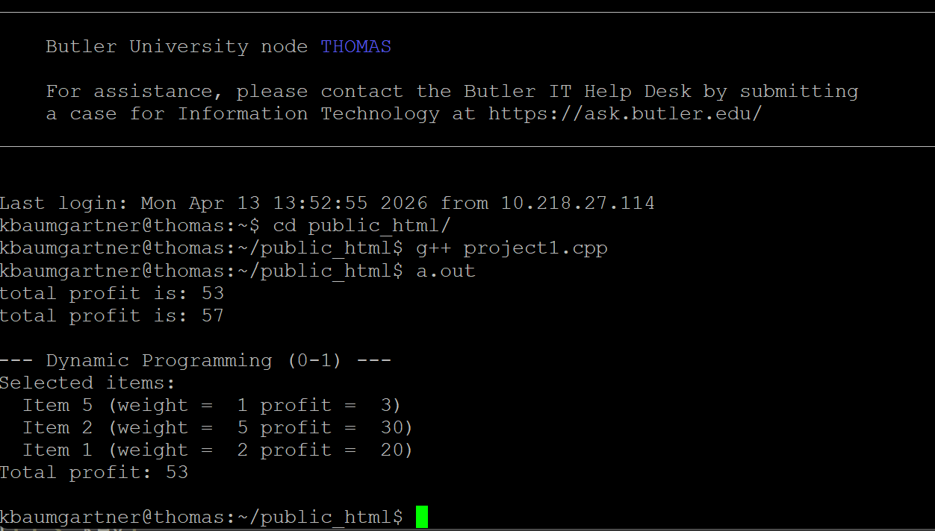

Dynamic programming needs to establish recursive property and using bottom-up approach to search for the solution. Dynamic programming can be slow, but it will obtain the optimal solution. The greedy algorithm will sort the items according to the given criteria and select items from the sorted list to get as many items as possible within the given capacity. Greedy algorithm is fast, but it may not obtain the optimal solution. Greedy with fractions allows you to split one item into a fraction. Overall, dynamic programming will give you the most optimal solution.

